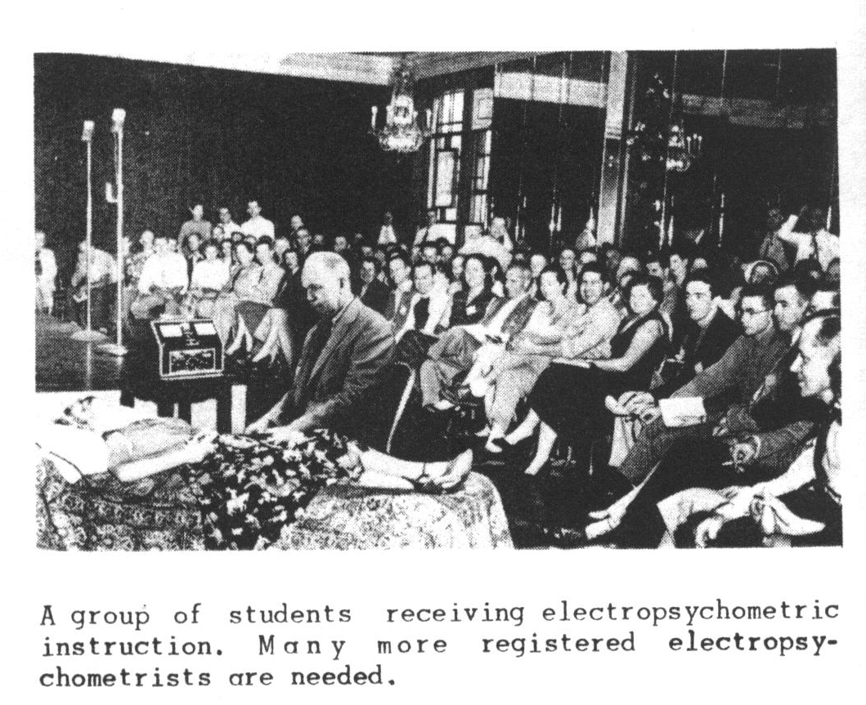
Chapter 6 Creative Image Therapy by Volney Matheson©1954
THE BODY IS THE INSTRUMENT OF THE PSYCHE
One peculiar situation sometimes is encountered in cases where creative image therapy is introduced to a patient who, unfortunately, has read books on the subject of psychoanalysis or psychiatry. Often such a patient will wanly inform you that he's sorry, but he can't visualize or create mental images to save his life. Not a one. It may be suspected that this type of patient is trying, in his aberrated way, to impress upon you the awful state of his case. He's bad off, so far gone he can't even visualize. He's putting you on notice--unless you are a super-thera- ist, you'll never be able to aid him. If you happen to get angry at the fellow, you might as well quit at once. But if you are just amused, you can agree with him. Inform him it's common, you have had such cases. Then with assurance and positiveness, try this: "In this situation there is a useful ubstitute. Merely imagine that you can see mental images. There's no question about it--you can't see them. But anybody unless dead or unconscious, can imagine or have an idea of what it would be like if he could create mental images." This sometimes works!
But herewith a more practical and effective procedure. Develop good understanding and rapport between yourself and your patient. Then execute the psychological maneuver illustrated in the following example.
The patient in this case was the wife of a foreign ambassador, an attractive but self-conscious woman who suffered from acute feelings of inferiority in the brilliant gatherings that she had to attend. She came to me by way of an official of our New York exporting firm, who previously had given her for reading one of my earlier manuals that dealt to some extent with mental-imaging, exercises. Then she had attended some "Scientology" group, where she found there was quite a to-do about 'mocking up", i.e., creating, various arbitrary systems of mental images. Listening meekly to the fictitiously self-assured gabble of this group about the extensiveness of their "mock-ups", she became convinced that in this circle, too, she was hopelessly inferior. Try as she would, she declared, she couldn't create mock-ups" or mental images. She hadn't even the slightest idea, she said, what such an experience would be like.
After taking special care to establish a very good relationship with her, I queried:
"Whom do you most love?"
"My oldest son," she replied, after a pause. "I love him dearly."
"Please describe your son to me," I requested her.
"What color is his hair?"
"Black."
"What color are his eyes?"
"Black."
"How tall is he?"
"Six feet exactly."
"How much does he weigh?"
"One hundred and seventy pounds, I think."
"Describe to me a time, if you can, when he appeared before your friends, or at a gathering, and you felt very glad and proud that he was your son."
"Oh.. yes ..." and she described a gala event in detail. Then I finally queried: "But how do you KNOW that his eyes and hair are black, that he is tall and slender, that he looked so fine in that gathering, and so on?"
"Why, lt she replied, unhesitatingly, "I CAN SEE HIM!" " "And that, 1" I replied, "is what is meant--and ALL that is meant--by saying that one is creating a mental image."
As I then painstakingly assured my patient, the diffi- culty seems to be, mainly, that persons who in general feel inferior, are apt, as has been stated previously in this book, to assume that a mental or psychic image should have much of the color, brilliance, intensity, and stability of a picture on a cinemascopic screen.
This is simply not the case.
Mental images are a rapidly duplicated series of exceedingly transient flickers. Each one is fleeting, evan- escent.
"But those" she exclaimed. "They are so filmy, such gossamer things. Thinner. than spider webs. hey no more than come and they are gone. How can such weak things have great power?"
The power of psychic images may not inhere in the transient images themselves. The power is perhaps that which creates the images. Each image is without weight, length, breadth, or depth, has no physical appurtenances apparently, and persists but a microsecond or so. Yet the creating and duplicating of such images initiates and accomplishes, in time, the physical act of CREATION.
The longer one considers the phenomena of creative imagery, on the level of awareness, the more clearly can one see that this activity is basic to almost every other. This, too, discloses the true nature of that which is generally called "faith". "Faith", in any religion, comprises the never-faltering duplication of psychic image systems wherein one is positively ALREADY ACCOMPLISHING SOME ACT, ACHIEVING SOME DESIRED EVENT. The mental images themselves are only of FULFILLMENT. These, the actual images, are as of NOW, only and forever as of now. They cannot be of the "future". One "sees" them NOW. In "faith cures" of actual disease, the psychic image pattern of the re-created structure is as of NOW. Not going to be, not will be, but NOW. Psychic images seem uncreatable 3.n the future sense. The image is created and duplicated NOW. The new structure is already completed--on the psychic image level.
If it is not first created on this level it will not be completed on the physical level. This is, must surely be, the mode of all Creation. The whole material universe is a manifestation of this prior creation by something that may be termed Divine Mind. It seems obvious that our physical bodies and all the structures that surround us--vegetable, animal, and mineral--are manifestations of some Creative Power. The body and everything physically pertaining to it is the instrument of the psyche. What other purpose can it have?
At this point, nearing the end of this book, the writer reluctantly presents a negative warning. There is extant a pseudo-scientific system of something or other wherein the patient is required to create and duplicate arbitrary sys- tems of mental images that are autocratically selected for him by the operator. Worse still, the patient is forced monotonously to perform interminably-duplicated trivial physical motions, such as touching a certain exact spot on the table, over and over and over, sometimes for hours.
Bluntly, this is a powerful and effective technique for covertly inducing hypnosis. By the duplicated command the subject is caused endlessly to duplicate mental image patterns wherein he is OBEYING the operator, explicitly, time after time after time. The subject is sooner or later reduced to such a zombie-like state that he will thereafter obey the operator's every other covert or indirect command. These covert and indirect commands are presented to the subject in the form of take-it-or-leave-it "suggestions"--to buy every book, take every expensive "course", attend every convention or conference staged by the operator. The victim at long last finds himself penniless, in debt, and much more ill and troubled than ever before.
The seizure of the intense attention of an intended victim by monotonously duplicated little acts is the tech- nique of the rattlesnake as he fascinates a bird. The snake sways back and forth, holding the victim's gaze, causing it to look from side to side, keeping its attention captive by this duplicative technique of fascination. A "fatigue point" eventually is reached. The snake's prey is thereby immobil- ized, psychically and physically--and devoured.
Unexpected diversionary situations also occur. The writer, determined as usual to "find out the facts", once made an appointment with a local female "graduate" of this touch-this-touch-that-as-I-comrnand-you school, and presented himself as a patient. The lady operator was incredibly attired--or rather unattired, for she had very little on-- and before long it became exceedingly obvious that she was not so much interested in having the "patient" touch a dirty spot on a chair or fondle a door knob as she was in having him touch things on her. This game, which has "playing postoffice" beat four ways from Sunday, could speedily lead into interesting but compromising goings-an. Further check- ing disclosed that at the "training center" of this concern, the mixed company of students, outside of formal school hours, might be suspected of engaging extensively in this and other equally bizarre "techniques".
Sex is nice--but the sexual embrace ought to be frank and whole-hearted, and not a corollary of some psychic-drug- ging procedure. Really, the sex phases of such a system are of no particular significance. What IS important is that the basic motive is to take the victim to the cleaners for every dollar he has or can beg, steal, or borrow. And itts incredible how much money the hypnotized disciples of a clever and ruthless operator will plead and beg of him to accept from them.
Don't be tricked by any faker, whether he claims to be holy, "illuminated", or "scientific". There are charlatans who promise--even through the U. S. mails, so stupidly reck less are they--to heal or transform you for large sums of money--some by esoteric "teachings", others by their mere presence or by their invoking some mysterious Power. The Power they claim to invoke is genuine--but it functions only within each of us. It was, is, and probably always will be here, unlimited.
The faker who hypnotizes you out of your money is not himself a sane, whole, and happy man--he is usually opera- ting, puppet-like, on some deep, uncleared set of sub conscious image patterns as brutal as those of some stray killer shark.
The power to create and to re-create is within each of us. It is not to be brought in through the door or the window by the wave of any man's hand, no matter how good or saintly a man he may in some cases actually be.
Creative Image Therapy
by Volney G Mathison
(c) 1954 by Matheson Electropsychometers International
Scanned and OCR'd by
Lermanet.com Exposing the CON
Letters to Lermanet.com

Hello,

I have been involved with Scientology, off and on, since 1976 and served on mission staff for a period of about 2 ½ years. In 2004, I decided to become active again and paid for a lot of training and auditing. All was going well and I was happy with the services that I was receiving.
I use the internet quite a bit for such activities as email, job searches, and research. I had never really looked at any of the anti-Scientology sites since as Scientologists we are told they contain entheta and lies. Anyway, I was a little curious about Ron’s death and decided to do a quick Google search. I was just curious, nothing else.
Back in 1986, at the event where Ron’s death was announced, I had felt a twinge of disbelief when I heard the speaker say that Ron had willingly departed his body so that he could continue his OT research. He said that Ron was in good health generally, but that these OT levels needed to be done without a body. We were told Ron researched how to discard the body and he wrote up the procedure so that we could all do the same when our time came. They said that Ron lay down on a bed, used his OT powers to stop the body’s functioning, and quietly passed away. At the time, I put aside my doubts since I knew that the tech worked, and also because I knew that questioning the church was frowned upon.
I knew that looking on the internet was considered out-ethics since it can expose the unwary person to upper level material. Since I had been in Scientology for many years, I felt I could easily skip any confidential upper level material on the internet. My first surprise was how many responses I received from my Google search for “death of L. Ron Hubbard”. My next surprise was that his death certificate and toxicology report were so readily accessible. Needless to say, I was quite surprised to see that he died of a stroke that took 8 days to kill him. I did not immediately believe that the church had lied to me at the event in 1986. I then came across Michael Tilse’s doubt formula and realized that other people had had similar doubts about this event. In my opinion, that gave the death certificate information credibility. A couple of weeks later, the ethics officer and DSA at the org confirmed what I had read on the internet. They showed me that the “vistaril” drug was used to treat Ron’s stroke symptoms. I did not really care about that. My concern was that it proved that the management had lied to the church membership about Ron’s death. The discovery of the lie was important.
The revelations about Ron’s death lead me to look further into other areas where I had felt something was a little off in the past. For me that meant the conviction of Mary Sue and the whole GO debacle. At that event, I was told that the church had mistakenly copied documents on a government copier and some people in the GO were convicted and had to serve a short jail sentence. The event made it sound like the prosecutors and the FBI were the bad guys and the GO people were being persecuted for making an error in using a copier. I left the event with the impression they went to jail because they did not furnish their own paper and inadvertently used the government paper in the copier thereby technically breaking the law. When I read about “Operation Snow White” and what really happened it proved to me that I had been lied to again. Later, I also saw that Mary Sue had admitted in court about the existence of GO Order 121689 that describes culling of PC folders. That was the moment for me where I realized I would never get any more auditing in the church. To break that confidentiality promise was unconscionable. It is interesting that the church says they never betray that parishioner/minister confidentiality, and yet there are numerous testimonials on the internet of ex-staff admitting to culling PC folders.
Before finding out about the culling of PC folders I found something else that was my turning point away from Scientology. I read the “Scientology – Through the door interviews” as well as other interviews on the internet. I never realized how many people had gone clear and OT and did not have any OT abilities. It wasn’t just a couple of dissatisfied PCs nattering on the net. I counted close to one hundred people who were clear or OT and had left Scientology. I knew their stories were true because I could identify similar experiences that I had had during my Scientology career. That is when the walls came crashing down for me personally, and I knew there was no bridge to total freedom. I was suddenly at the same spot that I had been at thirty years earlier just before I discovered Scientology. I had been searching for the answers to life. I wanted to understand life and help myself and others to live a better one. I had thought Scientology was the answer. Now I realize that the answer I had found was a fraud, and that I had been duped.
I would like to be able to turn back the clock and say that I never found out the church had been lying to me. I am an unwilling recipient of this knowledge. I even tried going back on course, but it was not the same. The bubble had been burst. Once outside, I could not go back inside.
I have had great wins on my auditing and training, especially Life Repair. My life changed so much on Life Repair that I decided that this was something I could do for the rest of my life. I believe this is also the point where I left my objectivity about Scientology and began to trust and believe what I was told without really examining or questioning any of it. Over the years I have endured a lot of the good and bad of Scientology. After a while, I would tell myself that the tech works and that that is what really matters. I would minimize and gloss over the bad stuff. When things like the church’s explanation of Ron’s death did not make sense, I did not pursue the matter. I closed my eyes to it. In fact, one of the reasons I got my grades expanded last year was because I wanted to be able to handle the bad stuff better. I knew the church would not change; therefore I needed to change, and to a large extent I did change. The expanded grades were really excellent and I had many wins. But they did not change the weird things that go on at the church. Lots of little, odd things occur like being forced to go to Sunday service, or the changes in the definition of a floating needle.
At any rate, I have decided to give the money I have on account to my ex-wife and walk away from the church. I would love to stay, but I don’t like liars. I have also decided to speak out about the church, the good and the bad. I am not sure to what extent at this point since I have seen what they do to those that speak out critically. But then what kind of church creates fear through intimidation. I feel I am becoming a truth seeker, critical thinker, and free speech advocate. It will be interesting to see where this road leads.

Here is a short write up of two items that concern me about the church. I have had great gains in my auditing and training and I find many things about the church that I like and admire. The following items appear to be indisputable facts.
Thanks,
Robert Thompson
When Mary Sue Hubbard and 10 Guardian’s Office members where convicted in Federal court, the church held an event to explain what had happened. In that event it was explained that the only thing illegal that had occurred was that the GO had used government office copiers without permission and that the 11 people were convicted of
"stealing photocopy paper."
www.lermanet.com/reference/77Granjurypart1.htm
This was simply not accurate. The chain of events are available on the internet, including the actual court documents.
lisatrust.bogie.nl/legal/snowwhite/index.html
en.wikipedia.org/wiki/Operation_Snow_White
When Ron dropped his body there was an event held to inform the membership of his passing. At the event it was explained that Ron had moved on to his next level of research, a level beyond the imagination and in a state exterior to the body. It explained that he had even written up the procedure so that other members could have this data when it was appropriate. There was no mention of him being ill. It was explained that this was a planned event so he could do further research into the upper OT levels without the encumbrance of a body.
Ron’s death certificate and toxicology report are easily found on the internet these days. Apparently, I was not alone in believing the documents could be forgeries. At least one and probably several Scientologists researched further by going to the San Luis Obispo Sheriff’s office and the county courthouse to view the reports personally. The facts are as follows:
1) Ron suffered a stroke eightdays before his death. (According to Gene Denk, Ron’s personal physician),
2) Ron had Vistaril, an anti-psychotic drug, in his blood at the time of his death. There were ten recent puncture wounds on his body from these injections,
3) Ron apparently had a history of acute pancreatitis, and developed dysphrasia just prior to his death. Dysphrasia indicates a difficulty in swallowing and can be caused by a variety of things.
4) Testimony from Robert Vaughn Young says that the PR story about Ron’s research into upper OT levels was created very soon after his death by church management to hide the true facts of his death.
Here is one internet site that has the coroner’s and toxicology report. http://www.xenu.net/archive/hubbardcoroner/
http://www.lermanet.com/reference/77Granjurypart1.htm
Interviews with some current and mostly former Scientologists.
http://alley.ethercat.com/door/

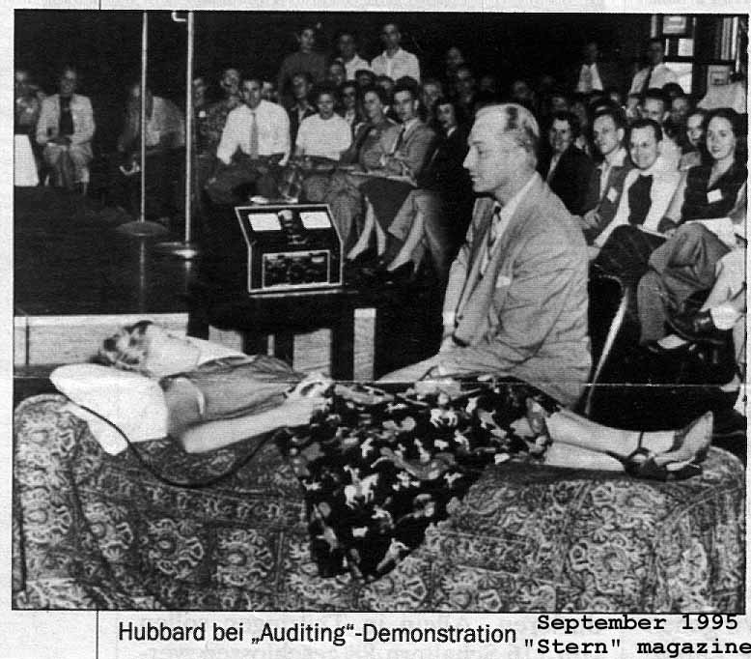

Picture to the left with Ron appeared in

Stern Magazine in September 1995.
The image inside with Volney was
From Volney’s own book in 1953!!

We come back, for our friends!
LERMANET.COM

6045 N 26th Road
Arlington Virginia 22207

